**<NBA data analysis and prediction model>**

Our analysis and prediction model are to help NBA fans see more visualized NBA players’ data and to provide reliable prediction model for making playoff games. The dataset we used includes all players stats from 1955 to 2018, and past MVP winners and NBA champions. Using these datasets, we addressed the following questions:

1. How many MVPs were winning conference and championships?
2. Which team had the most number of MVPs and the team with the most championships?
3. What position did the MVP play and those positions grouped by the era in which they played?
4. What are the trends of recent NBA games and what positions will likely be the most effective players for the team in modern games?
   1. Two-points attempts vs three-points attempts
   2. 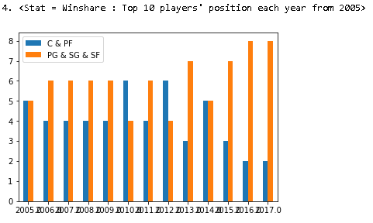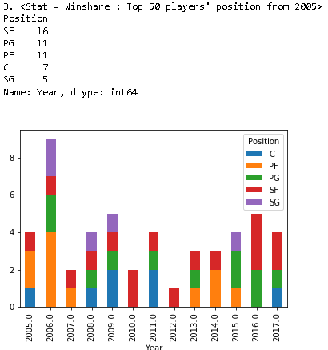Players’ positions with best win-share rate
   3. 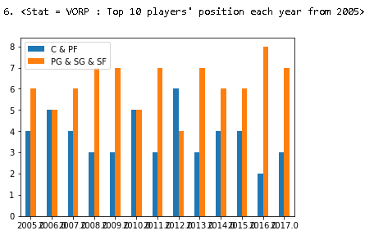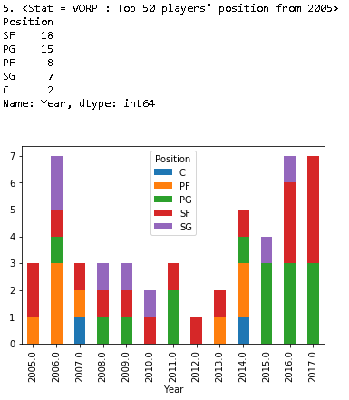Players’ positions with best VORP rate

* for analysis a), we used starting year of 1980 which is the year NBA first introduce the three-points rule to the league. The year can be changed based on user preference on line 73.

** for analysis b) and c), any years and any statistics (column name) will work with the model, such as BPM, 3P%, by replacing the year or field name on line 105 (for years) and line 113 and line 148 (for other statistics).

**How to use Playoff Prediction Model**

The plot created shows the linear relationship between win and point difference. Because of this linear relation we can build a model using linear regression. Next, we will show you our model fitting the dots. The red line is our fitted regression line. As you can see, our model explains relations between win and points difference in a very robust way.

Now, let's look at a table showing number of wins vs playoffs. To see how our model makes predictions, lets see a table of wins vs playoffs from past years. For example, there were only 2 teams winning 11 games and they never made it to playoffs in the past. As another example, 37 teams won 42 times and 29 of them made the playoffs only 8 team couldn’t make it. Hence, If you win 42 times, it is more likely that you’ll make the playoffs. Our data indicates that if you win 49 or more you’ll make playoffs 100 percent.

Now, we can look at some additional details of our model and make predictions. For instance, let's look at R squared of our model which is 94%. This means that our model explains most of our data. Now, we make predictions (This is our regression model). Let's make a prediction by entering average point difference of 35. You will win 42 times. As our prediction, as said before, based on past seasons, it is highly likely that you make the playoffs with 42 wins.

Our next model makes predictions for point scores, which is our final model, because of the time limitations. It is a simple model with few but significant variables to make predictions. its R squared is almost 90 percent.